**Project Report**

On

**“Pharmacy Management System”**

(using tkinter with sales analysis using pandas and matplotlib)

In

**Python**

**Submitted By :**

Divya

(Python )

**Table of Content**

|  |  |
| --- | --- |
| 1. | Declaration by student |
| 2. | Acknowledgement |
| 3. | Abstract |
| 4. | Requirement Specification |

**DECLARATION FROM STUDENT**

I**, DIVYA** hereby declare that project report on, **“Pharmacy management system (python)”**, which is being submitted in partial fulfillment for the certificate of industrial training, is the record of authentic work carried out by **Divya** during the period **from 20 May 2020 to 3 July 2020** under the guidance of **Jyoti Mehra *.***

I hereby declare that this project work has not been submitted before or for any other purpose.

*This is to certify that the above statement made by the candidate is correct to the best of my knowledge.*

**Jyoti Mehra**

**Acknowledgement**

I, **Divya** is using this opportunity to express our gratitude to everyone who supported us throughout the course of this project. I am thankful for their aspiring guidance, invaluably constructive criticism and friendy advice during the project work. I am sincerely grateful to them for sharing their truthful and illuminating views on a number of issues related to the project.

I express my warm thanks to **Jyoti Mehra** for her support and guidance .

It certainly was a big learning curve for us. Even though I did face many difficulties ultimately the careful planning and the dedication by which I was able to complete all the work. In the documentary I try and list the complete process that went into making the textpad into complete structure.

Thank you,

**Divya**

**ABSTRACT**

**What is PYTHON ?**

**Sources of PYTHON:-**

\

**ABOUT MY PROJECT**

**1st window -**

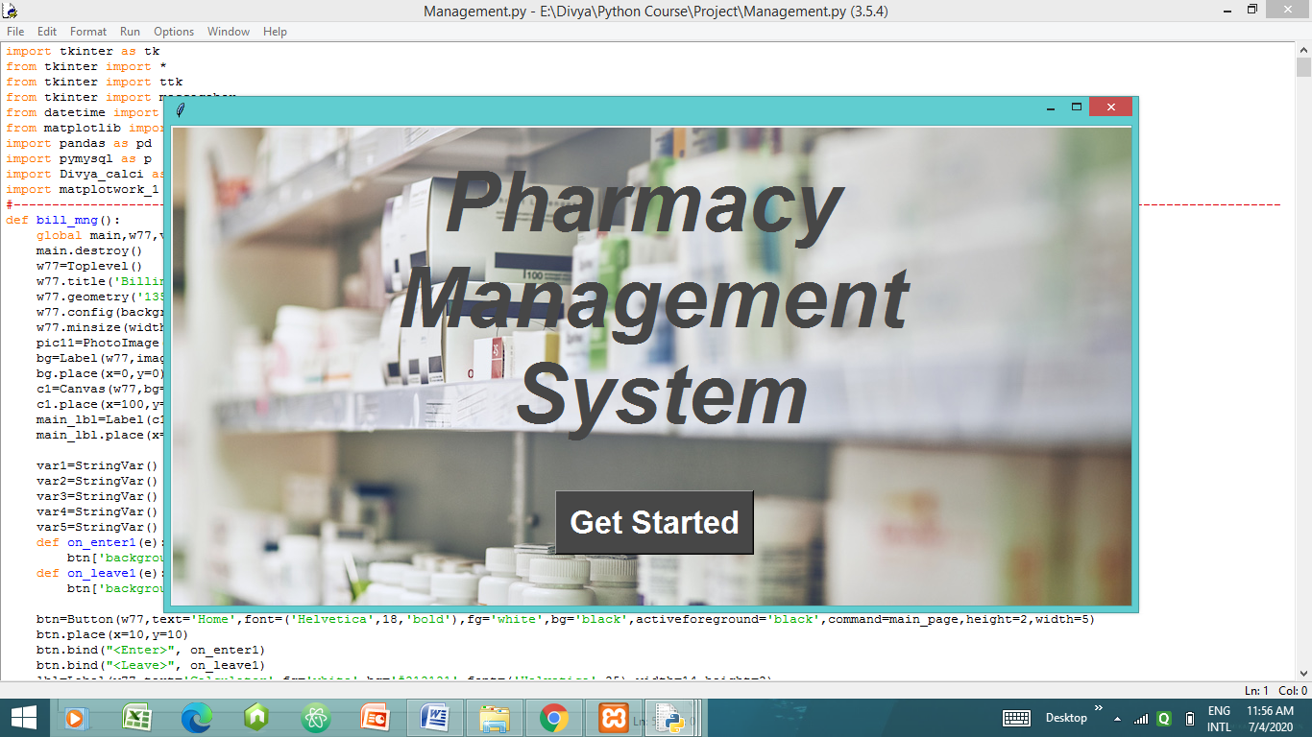

Here bind function is used to change the colour of button ‘Get Started ’ when we move mouse over the button.

def on_enter1(e):

btn['background'] = 'grey'

def on_leave1(e):

btn['background'] = 'black'

btn=Button(window,text=’Get Started’)

btn.place(x=10,y=10)

btn.bind("<Enter>", on_enter1)

btn.bind("<Leave>", on_leave1)

**2nd window - Login window**

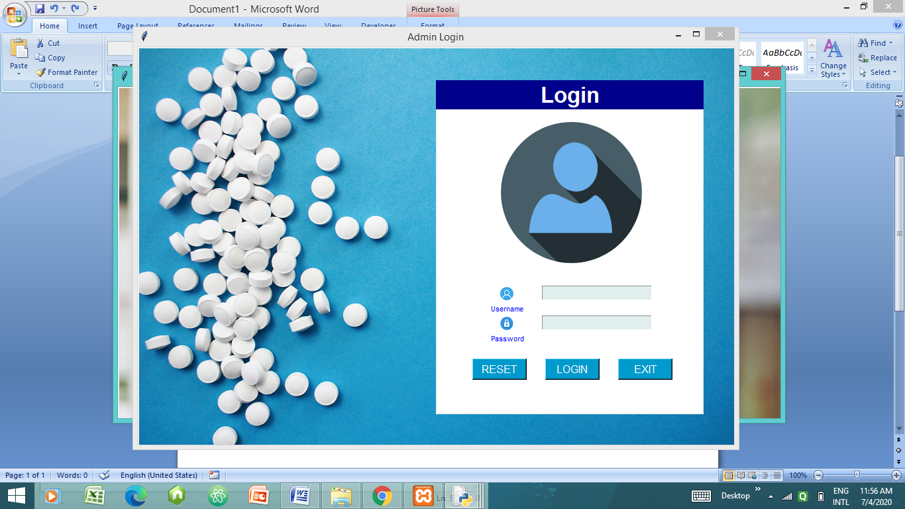

**Username : Divya**

**Password : Divya@11**

For wrong username password it displays -

“ Incorrect username and password ”

**Reset** : It clears the entry from username and password.

**Login** : For correct details it takes user to main page.

**Exit**  : It destroys the login window.

**3rd window - Main window**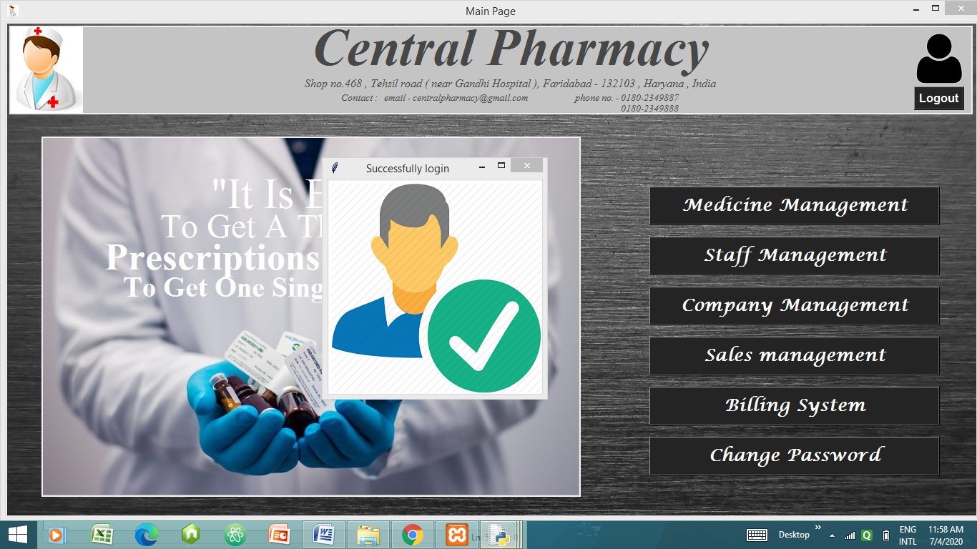

After login a *successfully login* login window opens and closes by itself .Here after function is used.

Below command is used to destroy (or perform any function) on the window :-

**w00.after(4000,lambda:w00.destroy())**

From this window we can access 6 more windows i.e. :-

* Medicine Management
* Staff Management
* Company Management
* Sales Management
* Billing System
* Change Password

**4th window – Medicine Management**

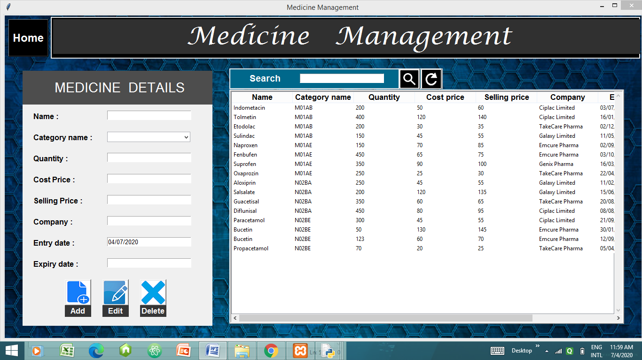

In this window the data of medicines is stored in the mysql database ‘***medicines***’.

**Widget Treeview** is used to present the stored data of medicines in presentable form.

* **ADD** - It adds the details given in entries corresponding to labels.
* **EDIT** - It edits/updates the details given in entries corresponding to labels.
* **DELETE** - It deletes the details given in entries corresponding to labels.
* **MENU** – takes user to the main page and destroys medicine window
* **SEARCH** – It displays datails of the medicine searched through name.
* **REFRESH** –It clears all the entries present on this window.

If all the entries/details are not filled then this messagebox is displayed to show  **‘*Data Missing’.*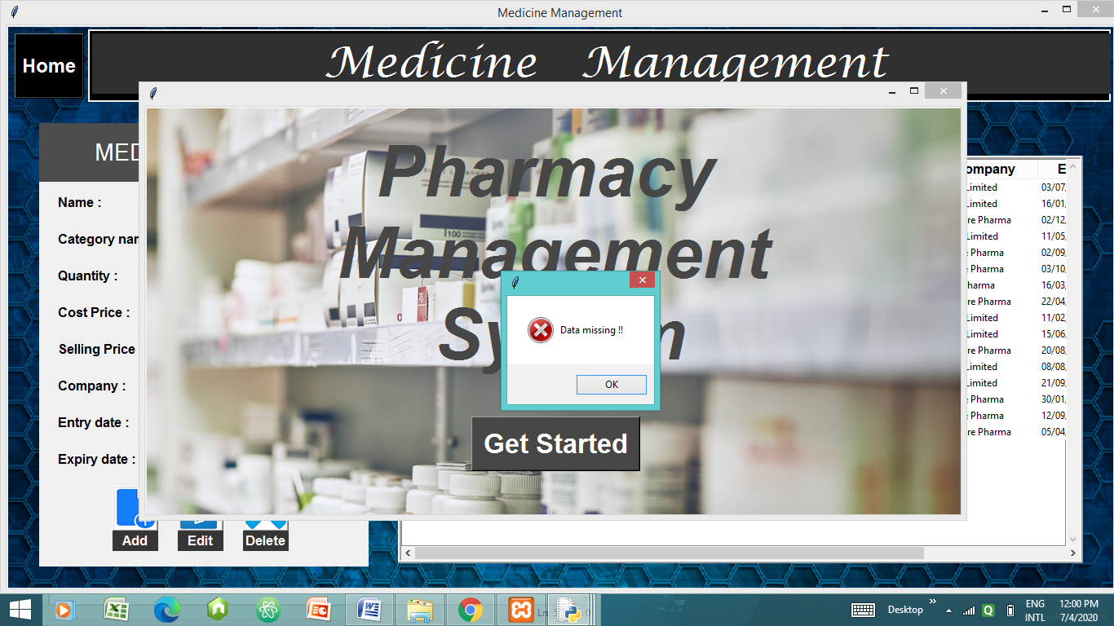**

If one medicine is searched then details corresponding to that medicine are shown-

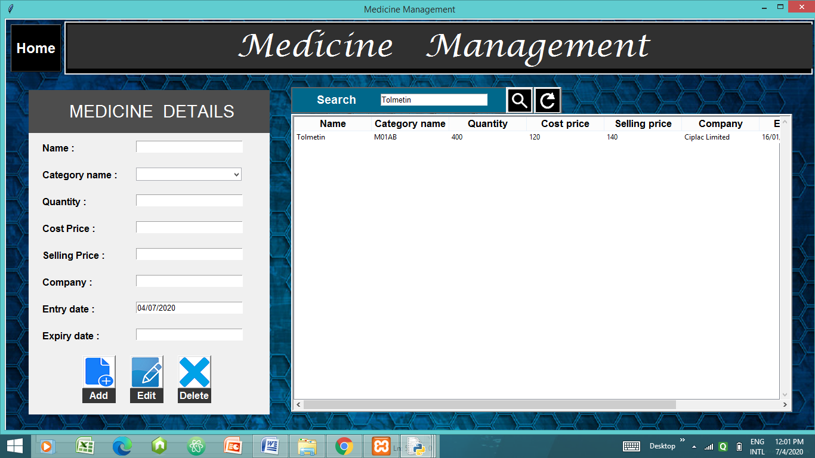

**5th window – Staff window**

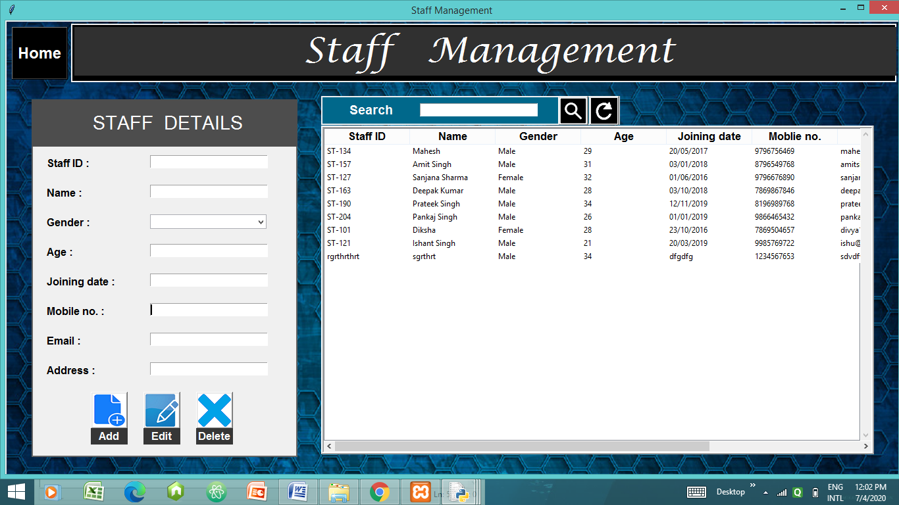

This window functionalities are similar to the medicine one. All the data of staff members working in the pharmacy are stored in the database ‘staff’.In this window we are required to enter both age and phone no. as integer otherwise it shows error ***–‘ Invalid phone number***.’

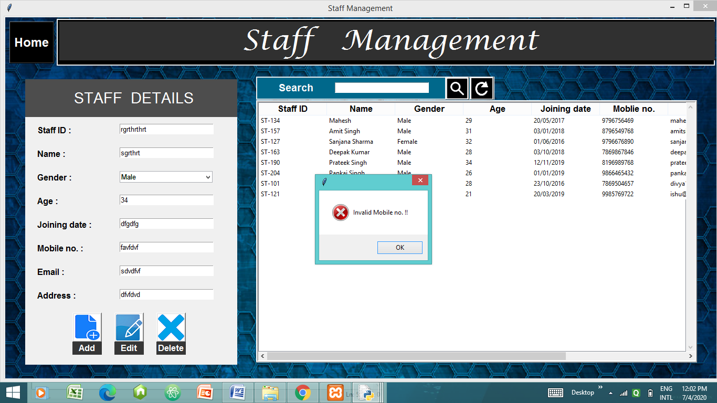

**6th window – Company Management**

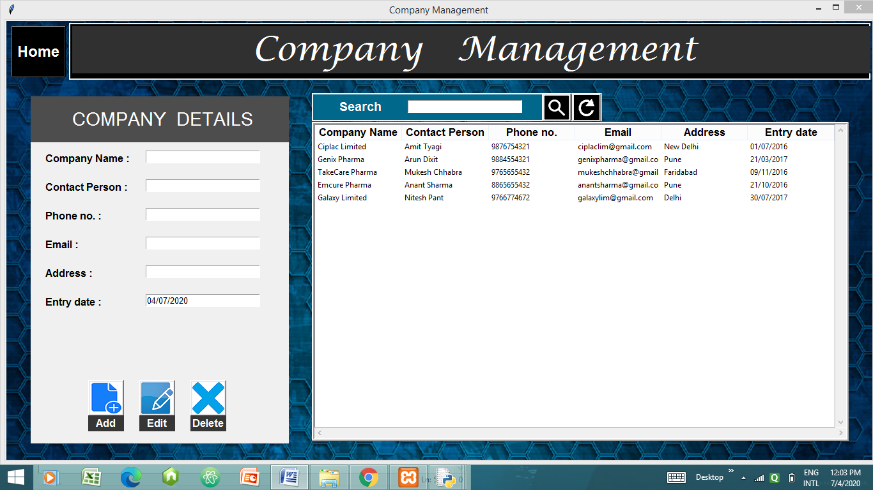

Functionalities of this window are same as medicine and staff window . We can add ,edit ,delete ,search any company name here.

The data about the company is stored in the table in database ‘company’.

We are required to enter phone number as integer otherwise it shows messagebox displaying error - ‘Invalid Phone number.’

**7th window – Sales Management**

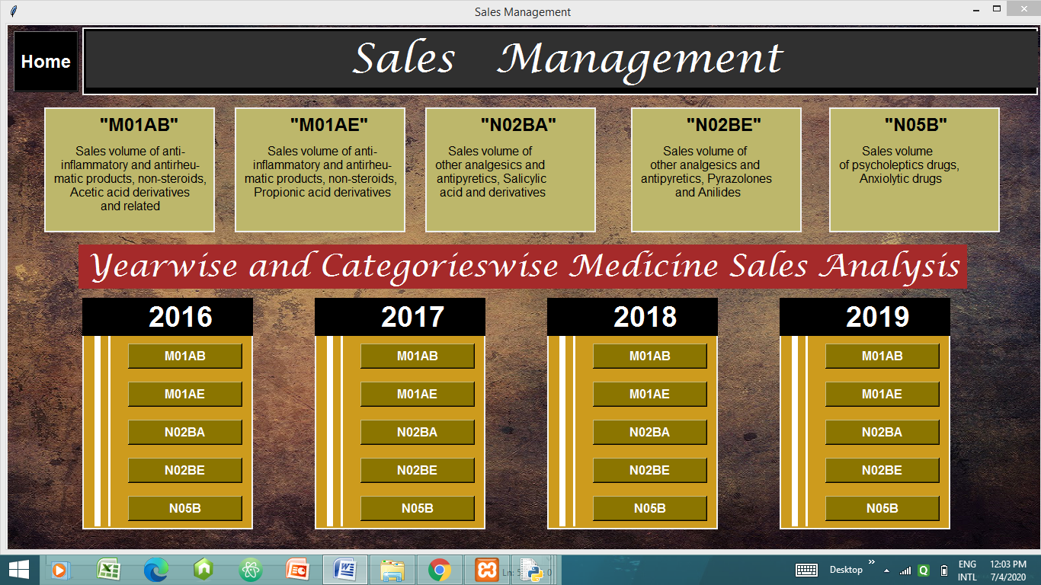

In this window all the categories of the medicines are mentioned.

Here, ***M01AB ,M01AE,N02BA,N05B are buttons*** that corresponds to graph.

I have taken dataset of a pharmacy of years 2016-19 .

So, using *pandas* I have shown the quantity of medicines sold of particular category in particular mentioned year.

A small level of analysis is done for the sale of medicines of central pharmacy.

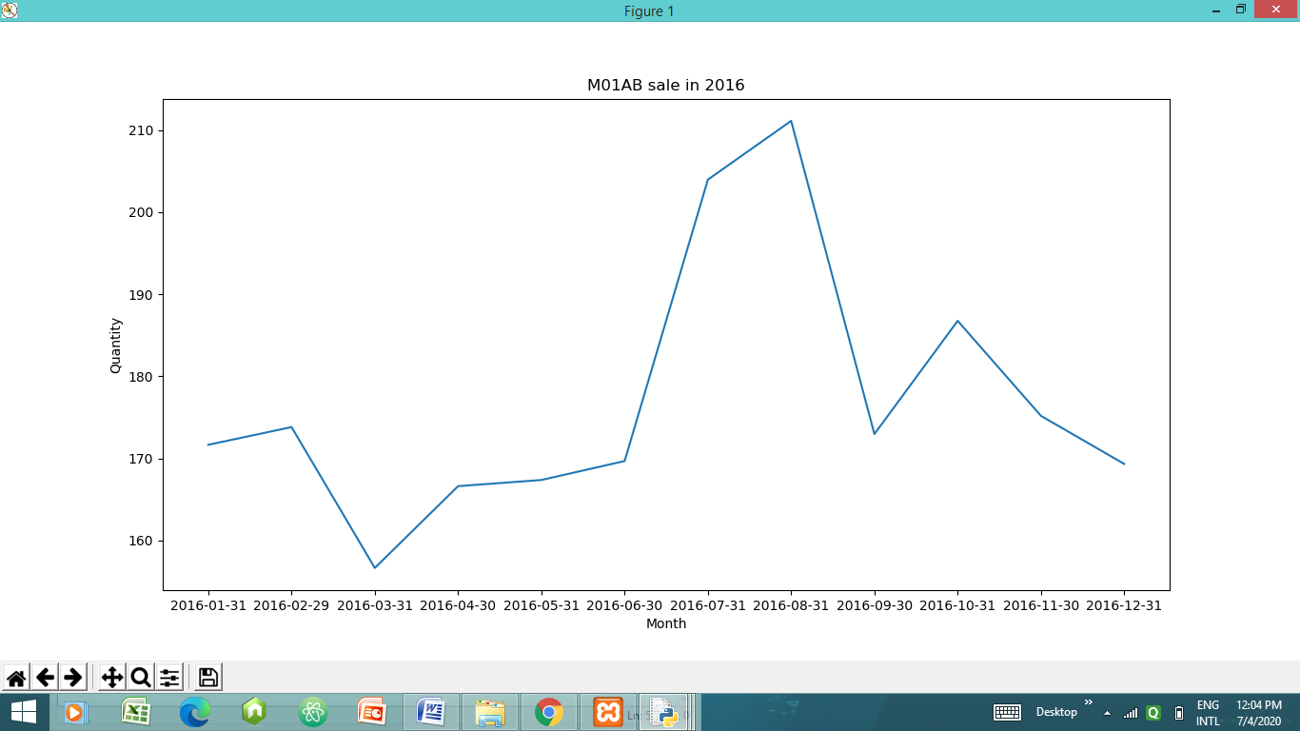

Matplotlib is used here to plot the data in the graphical form.

The title of this graph is *‘M01AB sale in 2016’.*

Here x-axis shows the month and y axis represents the quantity of medicines sold.

From this graph we can conclude that -

* In 2016 august month made greatest sale of medicines of category.
* March made the least sale.

Similarly, we can analyse the sale for all the categories of medicine from 2016-19.

**8th window – Billing System**

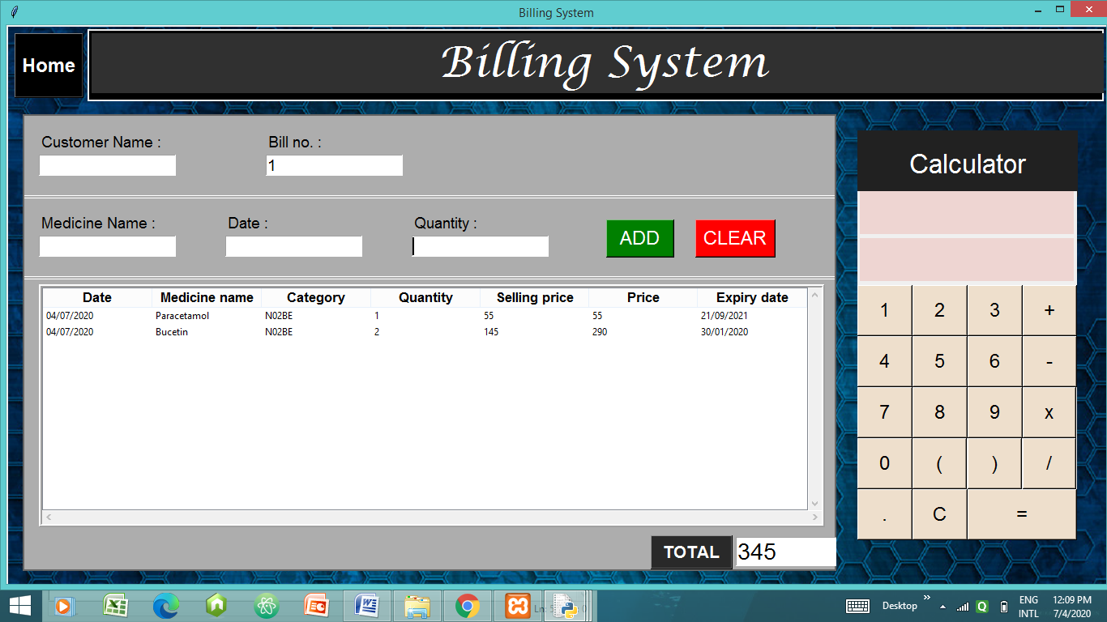

This window is the billing system . The owner can take entries of medicines and put it in the treeview. Here, Bill no acts as a unique identity for items sold at a time. The data of sale is stored in the database ‘billing’.

* **ADD** - It adds the datails of the medicine mentioned in the medicine name.
* **CLEAR**  - It clears all of the entries .
* **TOTAL** – It total the Price column values for each medicine and displays as total amount to be paid by customer.
* **MENU** – It takes user to the main window.

\*\**Calculator is also provided for the user.\*\**

**8th window – Change Password**

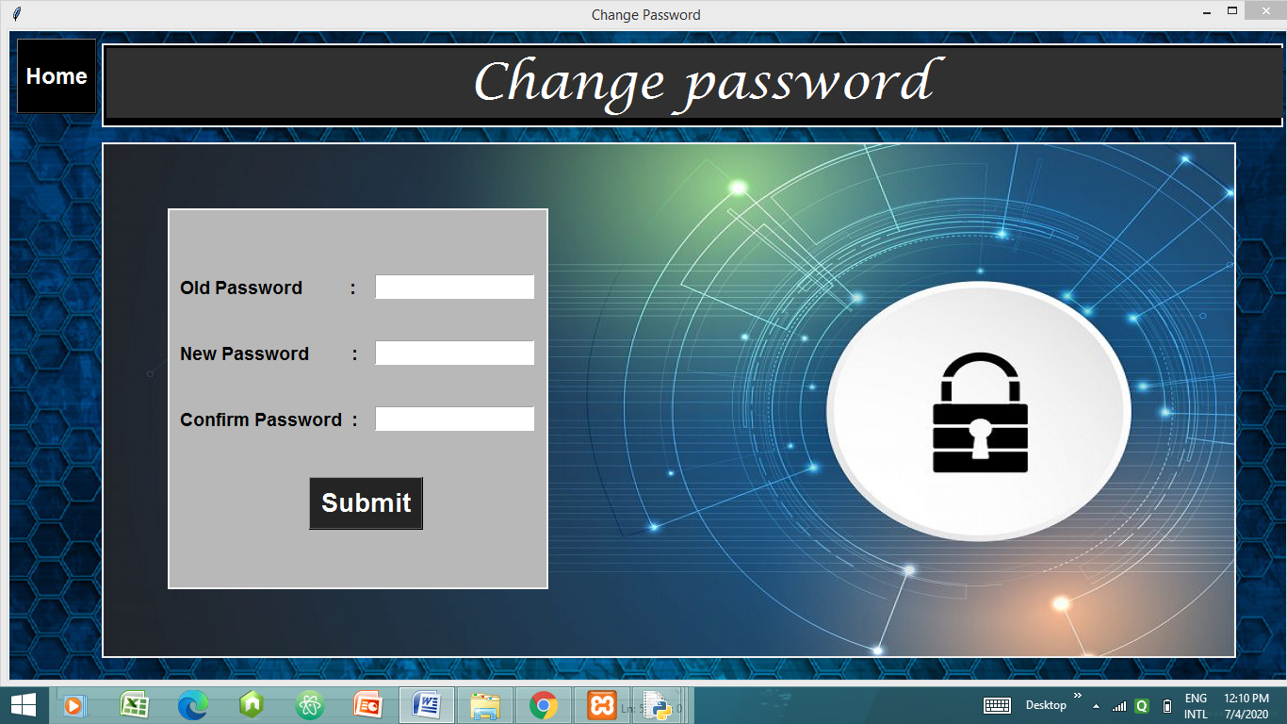

In this window user can change the login password by entering

old password and new password.

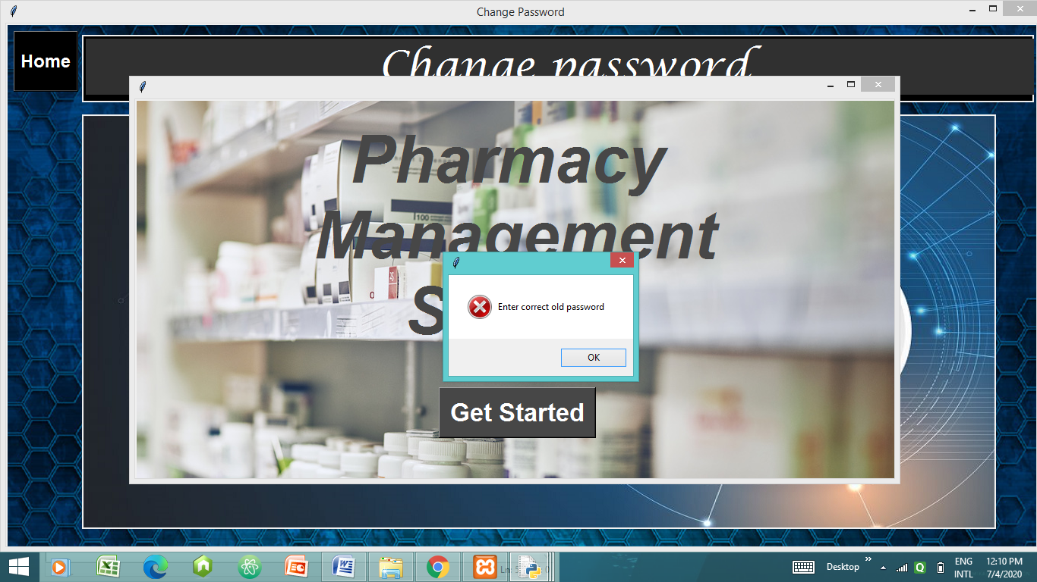

If incorrect old password is entered then messagebox is displayed showing error ‘Enter correct old password’.

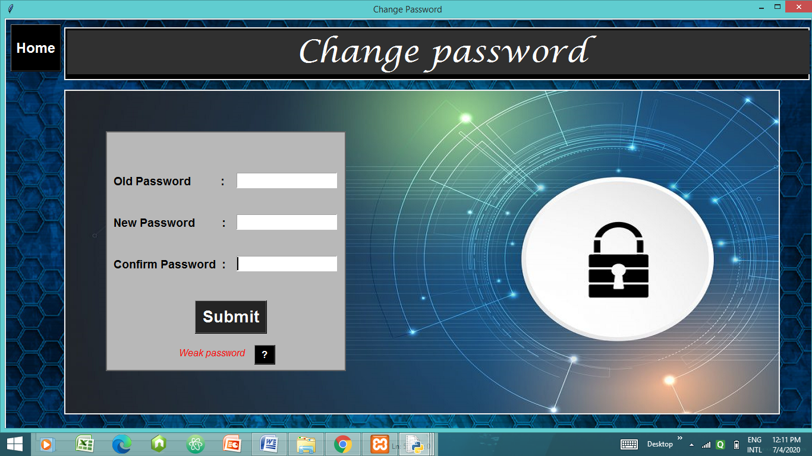

If correct old password is entered and a weak new password is entered then it shows the above screen.

After clicking the **button ‘ ? ’** a messagebox appears showing info-

“ Password must be at least 8 characters long.

It must contain at least one special character,one alphabet and one numerical value.”

After entering a strong password and if new password and confirm password are same then the password gets changed otherwise it shows error as - “ Passwords didn’t match. ”

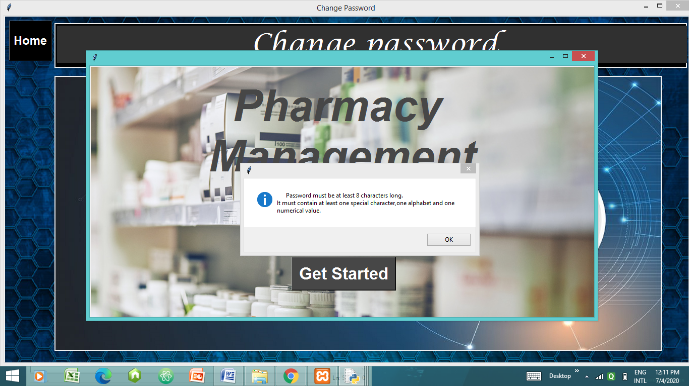

After successful change of password this window appears and we are back to login window.

